Configuring SCORE in SonarQube™

# *Catalyst Session Report*

# Preliminary Steps

## Add SCORE to SonarQube™

Read *Running the SCORE plugin*.

## Build a project to SonarQube™ using Hudson or Jenkins.

If you don’t want to additionally install and configure Hudson or Jenkins:

* Add your Sonar to an existing Hudson or Jenkins CI Server
* Copy an existing project on the CI Server
* Configure the copied project to point to your Sonar
* Build the project (make sure your Sonar is running when you do!)

The above instructions will be expanded. Until then, please use Google.

## Logging in as Admin

In order to configure the features provided by the SCORE plugin, you must login as admin.

In your browser, browse to the URL of your SonarQube™ Server. The login button is in the upper-right corner. Unless configured otherwise, the login and password should be “admin”.



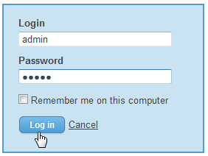

# Adding SCORE’s Widgets to Dashboards

## Dashboard and Widget Overview

### Cut to the Quick

* SonarQube™ displays information about projects on pages and on *Dashboards*.
* Dashboards can be customized by admin.
* A Dashboard can have one of two scopes: *Project* and *Global*.

### Navigating Dashboards

To view the global dashboards, click “Dashboards” in the upper-left corner.

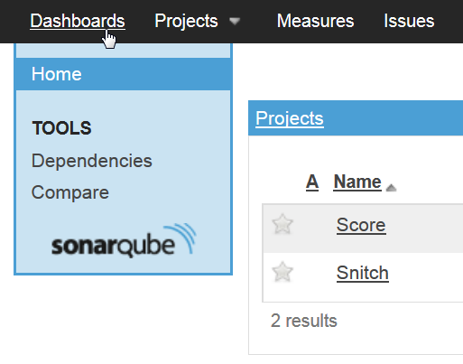

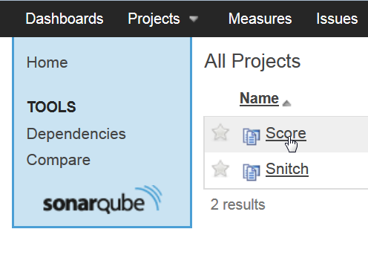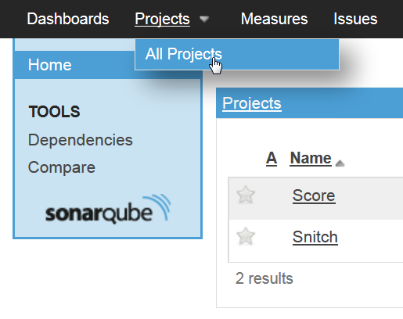To view the project dashboards for a project, click “Projects” and select a Project (if available), or select “All Projects” and then select a Project.

### Adding Widgets

To add Widgets, view a dashboard and click “Configure Widgets” in the upper-right corner. (If you do not see this button, you need to login as admin.)

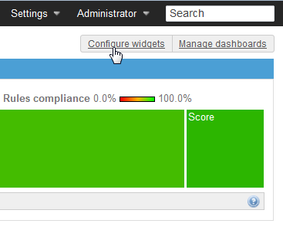

You can now configure the widgets on the dashboard, or add new ones. You can browse available widgets by category. You can find all the Widgets from the SCORE plugin under “Score”.

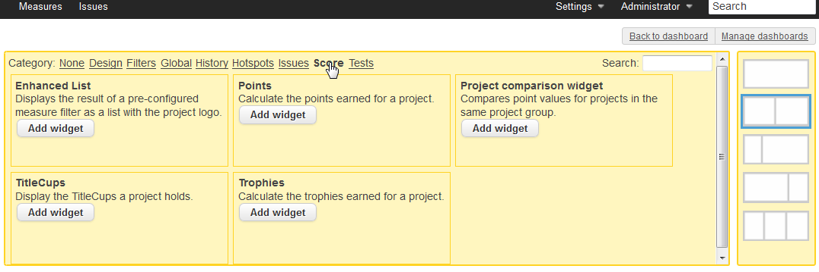

## Score Widgets

**Widget Dashboard Scope**

Enhanced List Global

Points Project

Project Comparison Widget Project

Title Cups Project

Trophies Project

# Configuring Awards

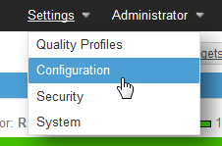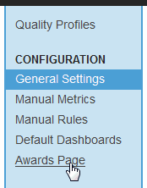Awards can be configured in the Awards Page. To view the Awards Page, go to Settings => Configuration, then in the side bar click “Awards Page”.

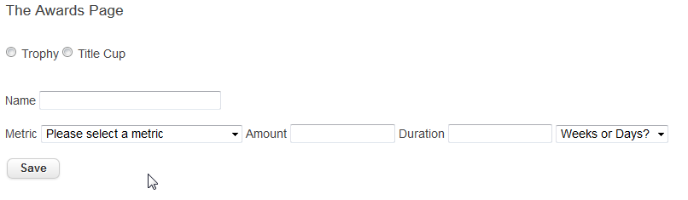

## How Awards Work

### Criteria

A Criterion for earning an award includes:

* A metric
* The amount that Project has to be at least as good as for that metric
* The duration of time in which the project has to have maintained that amount

If no amount or duration is specified, then the criterion is a “Best Of” criterion, meaning that only the project with the best amount of that metric will earn the Award.

An Award can contain multiple criteria. To do this, simply specify an Award of the same name and type but a different criterion. This will add the criterion to the existing Award.

### Trophies

Once a Trophy is earned by a project, that project keeps the Trophy forever, even if its stats later go down below the threshold to earn the Trophy.

### Title Cups

A Title Cup can only be held by one project at a time. For this reason, a Title Cup must have at least one “Best Of” Criterion (do this by not specifying an amount or duration).

# Configuring Project Groups

Projects need to be grouped with other projects for them to appear together on the Project Comparison Widget. To do this, view a project by navigating to its project dashboard (as described earlier), and then go to Configuration => Settings.

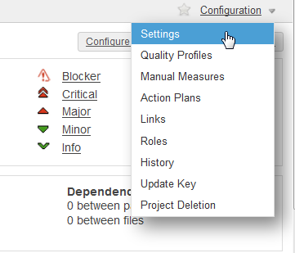

In the second side-bar, under Categories, click “Score”.

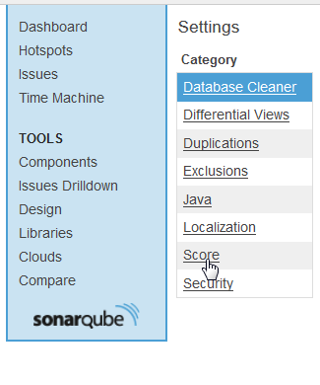

Enter a name to group this project and other projects under, and click “Save Score Settings”.

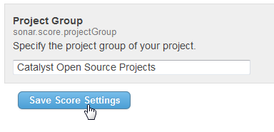

Do this for any other projects you want grouped with this one, typing in the same group name.

Finally, if you’ve added the Project Comparison Widget to the Project Dashboard, you should be able to see the results:

